**DEFINITION & DESIGN** **THINKING**

2.1Empathy Map:

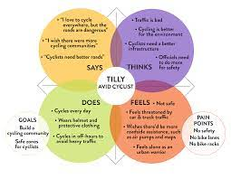

**IDEATION & BRAINSTORMING MAP**

